# Activity 2

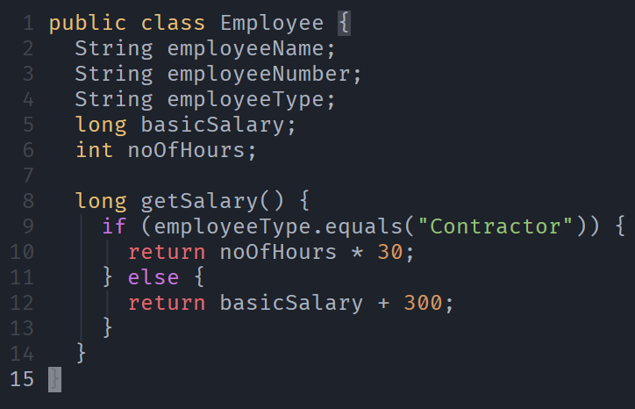

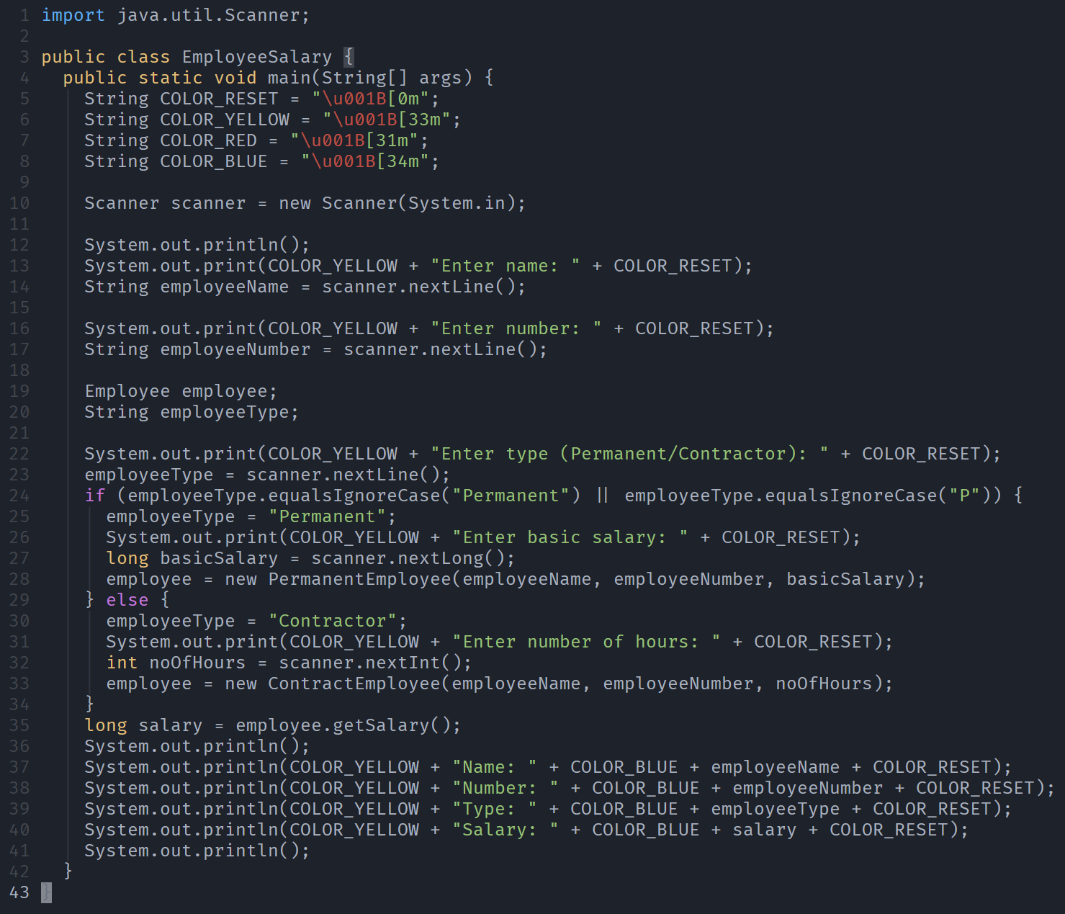

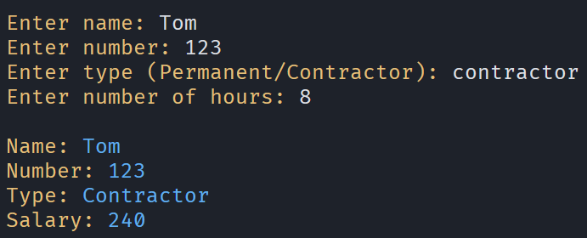

---------------------

| PermanentEmployee |

---------------------

| basicSalary |

---------------------

| getSalary() |

---------------------

|

--------------------- ---------------------

| Employee |------| EmployeeSalary |

--------------------- ---------------------

| employeeName | | |

| employeeNumber | ---------------------

| employeeType |

| basicSalary |

| noOfHours |

---------------------

|

--------------------

| ContractEmployee |

--------------------

| noOfHours |

--------------------

| getSalary() |

--------------------

# Activity 3

# Activity 4

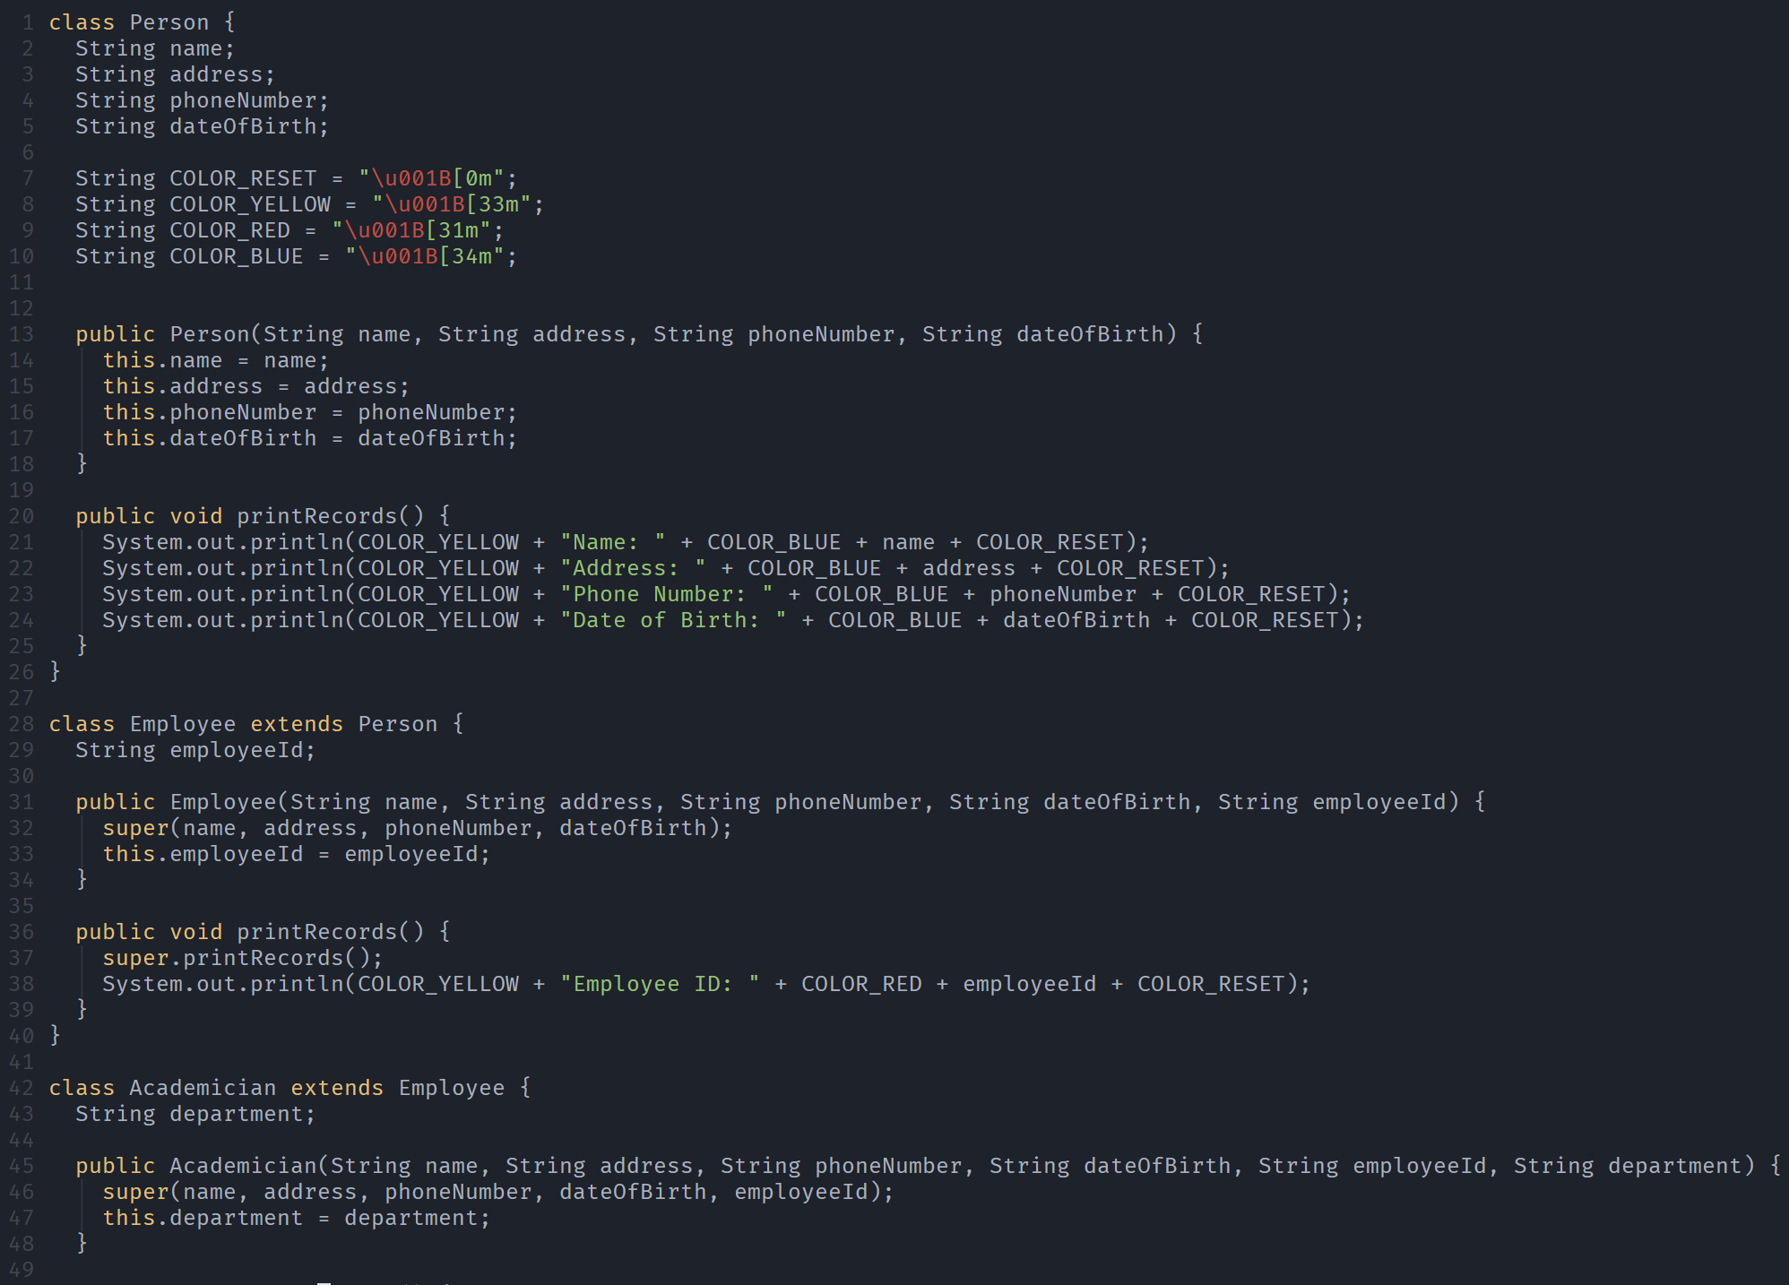

-------------------

| Person |

-------------------

| name |

| address |

| phoneNumber |

| dateOfBirth |

-------------------

| printRecords() |

-------------------

|

-----------------------

| |

------------------- --------------------

| Employee | | Student |

------------------- --------------------

| employeeId | | studentId |

------------------- --------------------

| printRecords() | | printRecords() |

------------------- --------------------

|

-----------------------

| |

------------------- --------------------

| Academician | | Administration |

------------------- --------------------

| department | | adminId |

------------------- --------------------

| printRecords() | | printRecords() |

------------------- --------------------

-----------------------

| Student |

-----------------------

| studentId |

-----------------------

| printRecords() |

-----------------------

|

---------------------------

| |

------------------------ ------------------------

| UndergraduateStudent | | PostGraduateStudent |

------------------------ ------------------------

| major | | degree |

------------------------ ------------------------

| printRecords() | | printRecords() |

------------------------ ------------------------

|

---------------------------

| |

------------------------ ------------------------

| DoctoralStudent | | MastersStudent |

------------------------ ------------------------

| researchTopic | | thesisTopic |

------------------------ ------------------------

| printRecords() | | printRecords() |

------------------------ ------------------------